# Competitor 2: Code Masters

# (**http://www.eng.unimelb.edu.au/engage/schools/codemasters**)

## 

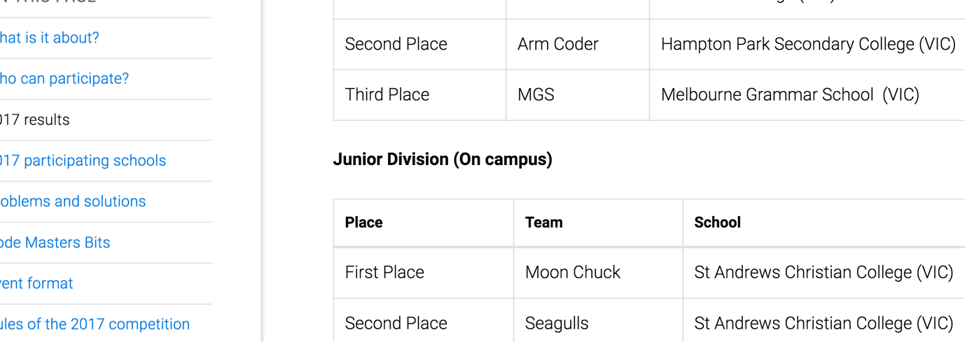

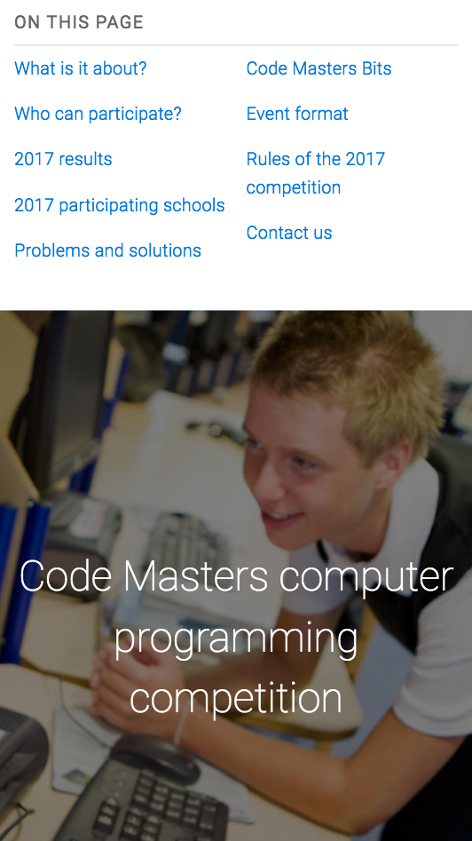

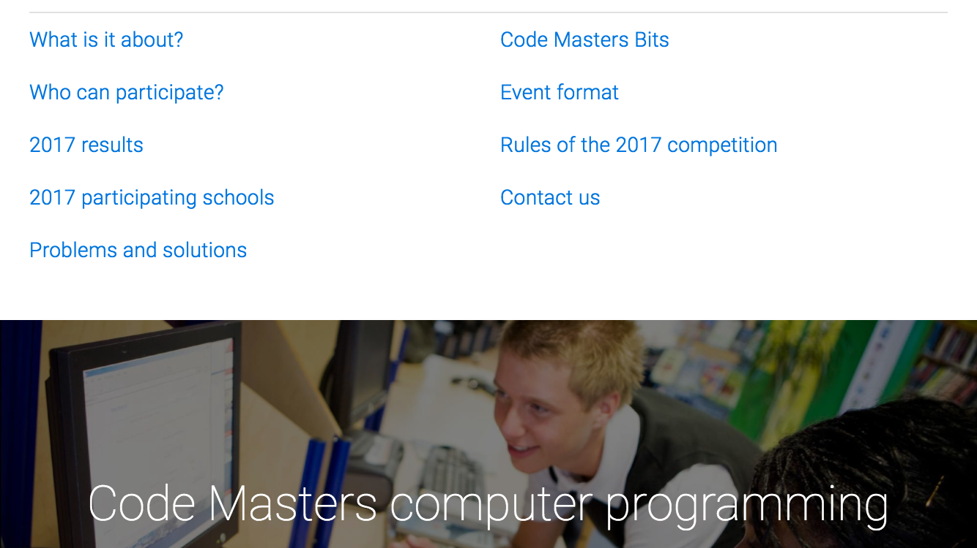

## Content/Functionality

The Code Masters website promotes the annual programming competition run by the School of Engineering at the University of Melbourne. It features all information for the competition on a single page, and has an easy to use in-site navigation menu, and search facilities.

Content and functionality specifics:

#### Information Offered:

* What is it about?
* Who can participate?
* 2017 Results
* 2017 Participating Schools
* Problems and solutions
  + Code Masters website – previous winners, leadership boards (lengthy) and problems / solutions. Registration. User management.
* Code Masters Bits
  + Code Masters Bits website - Currently run, all-year round competition with questions and leaderboard, rules. Team Registration.
* Event format
* Rules of the 2017 Competition
* Contact us

#### Technology Used:

* HTML5 and CSS3.
* Google Fonts.
* University of Melbourne styling (shared stylesheets).
* University of Melbourne shared JavaScript (common user functionality).
* Google Analytics.
* Isotope JavaScript layout.

#### Search Functionality:

* Easily seen. Prominently displayed upper right hand side of page.
* Available with JavaScript Enabled only.

## Strengths and Weaknesses

* Markup (HTML5)
  + Well written and easily understandable HTML5 markup.
  + Validation – passed.
* JavaScript / CSS
  + “No-js” fallback – designed for use without JavaScript functionality.
  + Polyfills – IE < v9.
  + With JavaScript off
    - Menu functionality moved (top right).
    - Layout at bottom of page stacked – not impressive visually.
    - Simplified Nav Bar – List contains no styling and looks primitive.
    - Main content remains accessible.
    - Search functionality removed.
  + Uses University of Melbourne js files and stylesheets.
    - Minimized CSS– difficult to analyse.
* Accessibility
  + Passes Chrome accessibility audit for most content.
    - Missing alternative text for some content.
  + Passes contrast testing 21:1 AAA.
* In-site navigation
  + Focused sidebar – focus adapts as page scrolls.
* Content
  + Similar requirements to ours.
  + Useful information.
  + Past events and results included.
* Top navigation
  + Inter-organizational navigation (Links for University of Melbourne).
  + Dropdown menu top right is visible and easy to find.
  + Search functionality top right is visible and easy to find.
* Responsive Design
  + Designed for mobile first.
  + Layout changes between device sizes.
  + Side menu moves to top as screen get smaller.
  + Some scrolling still required when side menu still on side.
  + Overall responsive site. Works well across devices
* Visual styles
  + Images / multimedia.
  + Easy to find search – done.
  + University Sitemap at bottom of page.
  + Performs well with styles removed.

## Strengths

* Mobile first, responsive design.
* Accessibility.
* Simplified markup.
* Style themes consistent with rest of organization.
* In-site location and navigation.
* Search functionality highly visible.
* Sitemap for organisation.

## Areas for Improvement:

* Site is insecure
  + No use of SSL for encryption.
* Accessibility
  + alt text required for all images
* Previous Events and Results– Not highlighted in a menu.
  + Labelled as Problems and Solutions, and positioned within the page content.
  + Could be labelled more appropriately and accessible via side navigation.
* Unobtrusive JavaScript
  + Provide Search functionality when JavaScript disabled.
  + Apply styling to top navigation links when JavaScript disabled.